DRINKING WATER DISTRIBUTION SYSTEM
SAMPLING PLAN (DSSP) FOR:

LA MESA WATER COOPERATIVE
PWS # NM3500123

PO Box 53
Placitas, NM 87043
(505)867-3335
hildecpa@comcast.net
Sandoval County

Original Plan Prepared By: Phillip A. Carter
Preparer’s Contact Info: (505)410-3266
email: watersysmgtinc@aol.com
Date Prepared: March 31, 2016
Date Submitted to NMED DWB April 1, 2016
Signature Phillip A. Carter

Reviewed by DWB SWIG Tech Services Coordinator Name
Date Recommended for Approval
Signature

Reviewed and Approved by DWB PWSS Group Compliance Officer
Date Approved
Signature

REVISION TRACKING

Original Plan Prepared By Phillip A. Carter
Date Prepared March 31, 2016

1st Revision By Phil Carter
1st Revision Date December 28, 2022
Date Submitted to NMED
Date Approved by NMED

2nd Revision By
2nd Revision Date
Date Submitted to NMED
Date Approved by NMED

Table of Contents
Section 1: System Description and Contact Information 1
Section 2: Bacteriological Sampling 3
Revised Total Coliform Rule (RTCR) Sampling 3
Groundwater Rule (GWR) Sampling 4
Section 3: Disinfectant Residual Monitoring 7
Section 4: Lead and Copper Rule (LCR) Sampling 9
Section 5: Disinfectants/Disinfection By-Products (D/DBP) Rule Sampling 10
Section 6: Entry Point (EP) Chemical Compliance Sampling for Organics, Inorganics & Radiologicals 12
Section 7: Distribution System Asbestos Sampling 15
APPENDIX A: System Sample Schedule from Drinking Water Watch 17
APPENDIX B: RTCR Sample Sites Spreadsheet 18
APPENDIX C: Sample Sites 21
APPENDIX D: Alternate RTCR Repeat Sampling Sites SOP 27
APPENDIX E: Disinfectant Residual Report 28
APPENDIX F: Guidelines for Lead and Copper Site Selection and Sampling 29
APPENDIX F: Suggested Directions to Homeowners for Sample Collection 32

Table of Figures
Figure 1: SYSTEM SCHEMATIC 2
Figure 2: Well #5 Raw Water Sample Point 5
Figure 3: Well #6 Raw Water Sample Point 6
Figure 4: Well #5 Entry Point 13
Figure 5: Well #6 Entry Point 14
Figure C.1: RTCR Routine Sample Sites 21
Figure C.2: RTCR Repeat Sample Sites 22
Figure C.3: GWR Triggered Source Sampling Sites 23
Figure C.4: Chlorine Residual Monitor Sites 24
Figure C.5: Lead and Copper Sample Sites 25
Figure C.6: D/DBP Sample Sites 26

Section 1: System Description and Contact Information
The La Mesa Water Cooperative owns and operates two active groundwater wells. The water system serves 650 people with 335 connections. Water from the wells is disinfected with a 6% hypochlorite solution prior to being pumped into the distribution system, as well as to the 2 above ground storage tanks. The storage capacity of the storage tanks is 300,000 gallons. Water from the tanks gravity flows to the majority of the distribution system. A small portion of the system, approximately 40 homes, receives pressurized water from 2 booster pumps in conjunction with 6 pressure tanks. Pressure reducing valves are utilized to reduce the distribution pressure in two distinct pressure zones.

Our current sample schedule from Drinking Water Watch is provided in Appendix A.

 | Hilde Penhallurick
PO Box 53
Placitas, New Mexico 87043
 | (505)867-3335
 | email:hildecpa@comcast.net
Certified Operator: | Phillip A. Carter
P.O. Box 10657
Albuquerque, New Mexico 87043
(505) 410-3266
email:watersysmgtinc@aol.com
NMED-DWB Contact | Frank Baca  Harrold Runnels Building  1190 St. Francis Drive  Suite S2050  Santa Fe. New Mexico 87505  (505) 469-1323  email:Frank.Baca@state.nm.us

SYSTEM SCHEMATIC

WELL 5
RW CL2 EP

DISTRIBUTION
200,000
Gallon
Storage
100,000
Gallon
Storage
BOOSTER PUMP HOUSE
PUMPS/PRESSURE TANKS

WELL # 6
RW CL2 EP
DISTRIBUTION
PRESSURE SYSTEM

Figure 1: SYSTEM SCHEMATIC

Section 2: Bacteriological Sampling

Revised Total Coliform Rule (RTCR) Sampling
Frequency
Based on our population of 650 and the sample requirements provided in Tables 1 and 2 of the instructions, we are required to designate a minimum of 4 routine sample locations per month and collect a minimum of 1 routine bacteriological samples per month. Due to the size of the La Mesa Water Coop water system, the various gravity pressure zones, and the separate area entirely on a booster pump system-the system has designated 12 routine sample locations.

Location
We are required to identify each of our routine monthly bacteriological sample locations, and the three (3) repeat sites (original, up- and downstream) associated with each routine site with either a physical address or physical location. Those addresses/physical locations are listed on the RTCR Sample Site spreadsheet in Appendix B. That spreadsheet has been submitted to the DWB according to the instructions that accompanied the spreadsheet; the submittal acknowledgement is included in Appendix B.

Appendix C includes the map(s) showing where these routine and repeat sites are located throughout our distribution system.

We understand that the DWB will be verifying that we sample from each routine and repeat sample location designated on our DSSP. We further understand that our DWB Compliance Officer will also verify that we collect the routine samples at regular intervals from month to month (i.e., same week each month) and that we are rotating through each major and minor portion of the distribution system.

Alternate Repeat Sampling Locations
The RTCR Sample Site Spreadsheet in Appendix B designates repeat sample locations that are within the five (5) connections up- and downstream of the original routine sample location. However, we understand that we can use alternate up- or downstream repeat sampling locations that are outside the five (5) connections from the original sample site as long as we submit a Standard Operating Procedure (SOP) that specifies our criteria for selecting these alternate repeat sampling sites on a situational basis (i.e., for any time we are required to collect repeat distribution system samples and determine that the prescribed repeat locations do not adequately identify potential pathways of contamination).

We do not plan to use any alternate repeat sampling sites.

Seasonal Systems
Seasonal systems are systems that start up and shut down at the beginning and end of a specific operating season and may depressurize all or part of the water system at some point during the year.

We are not a seasonal system.

Groundwater Rule (GWR) Sampling
One (1) Triggered Source Water sample is required to be collected from every active well if any of our routine monthly samples test positive for Total Coliform (TC) or E.Coli (EC). These Triggered Source Water Samples will be collected directly from each of our wells prior to any treatment and are shown on the map(s) in Appendix C. Our sample points are labeled as “Raw Water” as shown in the photographs below.

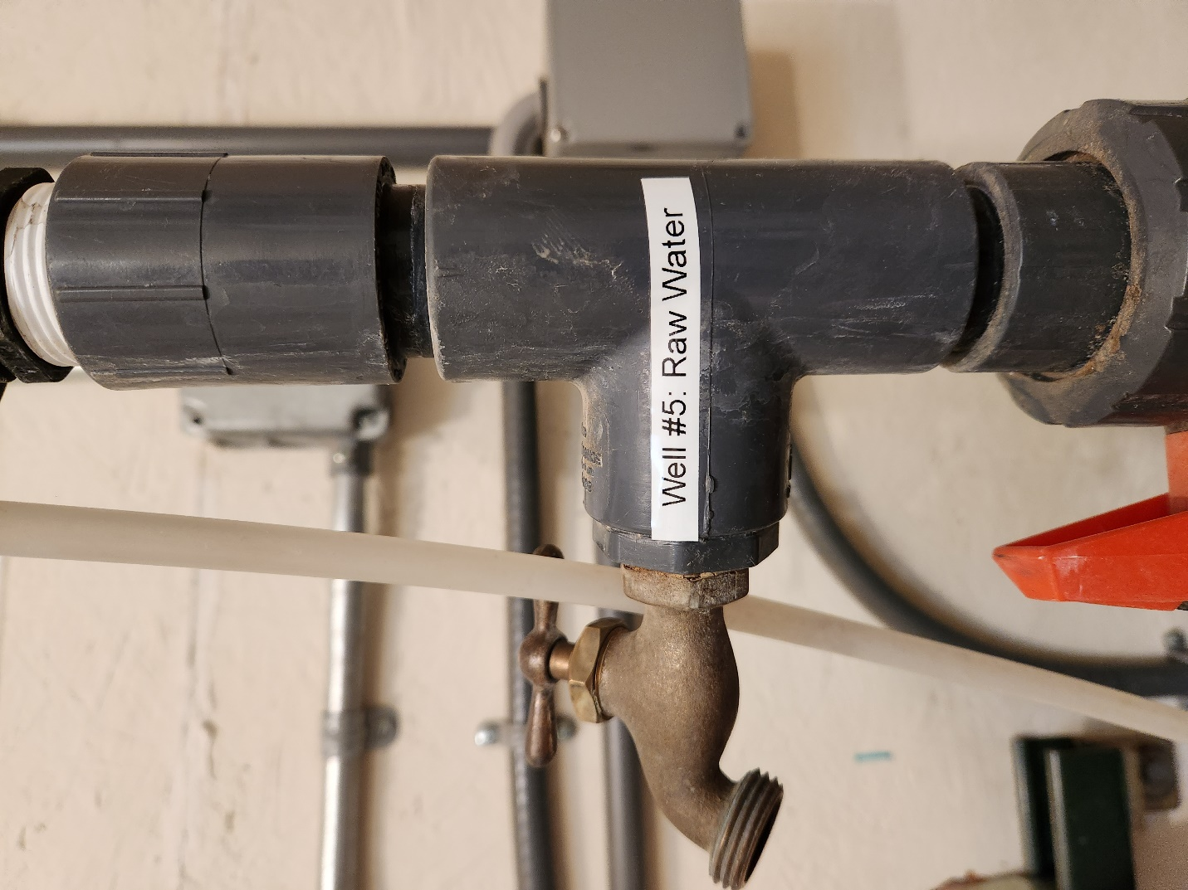
Figure 2: Well #5 Raw Water Sample Point
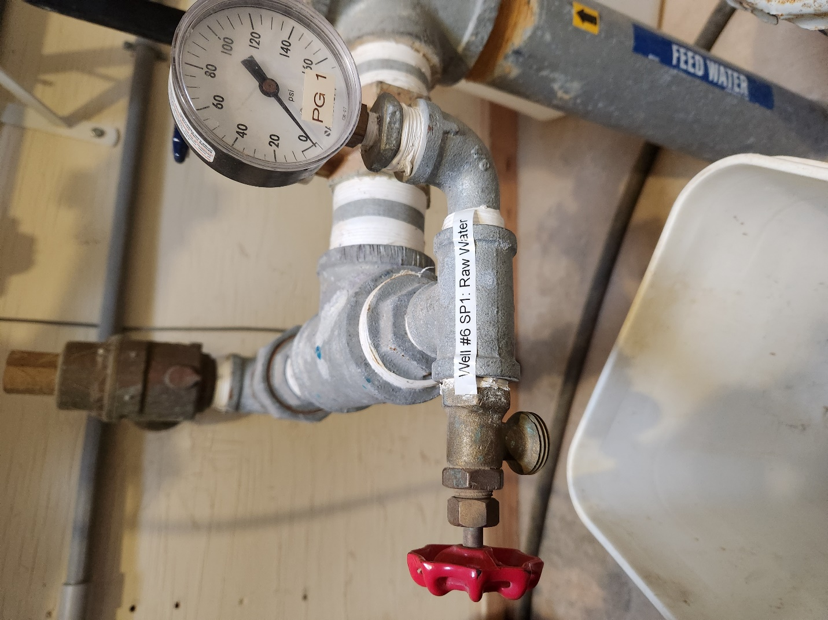
Figure 3: Well #6 Raw Water Sample Point
Sampling Requirements
New Mexico Regulations require that a certified sampler or certified operator collect the RTCR and GWR samples. Because of this requirement, our certified operator will be required to collect our bacteriological samples. Once collected, our operator will submit the samples and their Chain-of-Custody (CoC) forms to the following certified laboratory within 24 hours of the sample being collected:

Environmental Testing Services
4501 Bogan Avenue NE, Suite A2
Albuquerque, New Mexico 87109
(505)881-0243

Compliance Status
RTCR
Our water system triggers an assessment with the RTCR if:
- We get 2 or more TC+ samples in any one (1) month (for systems that take <40 samples/month);
- >5% of our routine samples are TC+ (for systems that take 40 or more samples/month;
- We fail to take all the required repeat samples
- Any one (1) of these conditions will trigger a required Level 1 assessment/correction action

A Level 2 assessment/corrective action is triggered if we get:
- An EC Maximum Contaminant Level (MCL) violation; or
- An EC monitoring violation; or
- We trigger two (2) Level 1 assessments within a rolling 12 month period

GWR
We are in compliance with the GWR if our Triggered Source Water sample(s) are free of EC.

We will immediately notify our DWB CO if any of our Triggered Source Water samples test positive for TC or EC. At that time, we can be required to conduct additional sampling, correct significant deficiencies, or disinfect our water to meet 4-log treatment requirements.

Section 3: Disinfectant Residual Monitoring
Frequency

We are a chlorinated system, and as such we are required to measure chlorine residuals at the same time we collect our monthly routine RTCR samples. We also measure chlorine residuals throughout the month as part of our best management practices.

Based on our population of 650 and the requirements provided in Tables 1 and 2 of the DSSP template instructions, we are required to designate a minimum of 4 chlorine residual monitoring locations per month. Due to the size of the La Mesa Water Coop water system, the various gravity pressure zones, and the separate area entirely on a booster pump system-the system has designated 12 residual monitoring sample locations.

Location
Chlorine residuals are measured at the same time and from the same locations where we collect our routine monthly RTCR samples. Results are recorded on each bacteriological CoC form and submitted to the lab with those samples. The sites were chosen based on the fact that they are representative of the entire distribution system, and are designated on the map(s) included in Appendix C.

We also measure chlorine residuals at the 3 chlorine residual monitoring sites throughout the month as part of our best management practices. This is to ensure that injection dosages are sufficient to meet chlorine demand and maintain adequate residuals in the entire distribution system, including vulnerable portions of the system. Vulnerable areas are anywhere we might have increased water age or stagnant water (storage tanks, high elevation/low pressure, low occupancy, dead ends). We use these chlorine residual results along with other information to focus our best management practices such as line and hydrant flushing (along with valve exercising).

Methodology and Reporting
Our certified operator uses a Hach Pocket Colorimeter II to measure chlorine residuals and follows all sample collection, handling, measuring and equipment calibration protocol specified in the operation manual.

All chlorine residuals that are measured during RTCR routine and repeat sampling and for best management practices. These results are required to be recorded on the bacteriological chain of custody forms that are submitted to the lab and are also recorded on the Residual Disinfectant Residual Measurement Sampling Report (Appendix E). We submit this report to our DWB CO by the 10th day following each quarter, as required.

Compliance
Our water system is in compliance if:
- We maintain chlorine residuals less than or equal to 4.0 mg/L, the Maximum Residual Disinfectant Limit (MRDL)
- We submit our Residual Disinfectant Residual Measurement Sampling Report to our DWB CO no later than the 10th day following each quarter

Section 4: Lead and Copper Rule (LCR) Sampling
Frequency
We are required to collect ten (10) Lead and Copper samples once every three (3) years. We use Drinking Water Watch to keep track of this sampling schedule (Appendix A).

Location
Sample locations are based on the age and types of structures we have in our community, including schools. We have included guidelines for site selection and sampling in Appendix F of this plan. Based on these criteria we have selected the main and alternate locations designated in the following table for every Lead and Copper sampling event. These locations are also designated on the map(s) in Appendix C.

Site Number | Address
1 | 02 Calle Cobre
2 | 15 Calle Corvo
3 | 66 Camino Barranca
4 | 6 Valley View Court
5 | 03 Dustin Court
6 | 11 Calle Pinon
7 | 7 Calle Cholla
8 | 16 Calle Colores
9 | 46 Camino Barranca
10 | 127 Camino Barranca
Alternate Sites
ALT | 02 Calle Pinon
ALT | 02 Calle Ponderosa
ALT | 96 Camino Barranca
ALT | 08 Calle Pinon
ALT | 165 Camino Barranca

Methodology
Sampling protocol requires that these samples are:
- Point-of-Use (POU) collected directly from the customer’s tap
- Collected as a “first draw” sample before any other usage takes place at the sampling tap (no flushing of faucet or lines before collection)
- 6 to 18 hours old in customer’s plumbing
- Typically collected by occupant of sampling location
- Typically collected during third quarter warm weather months July to September

In order to meet these sampling protocol our certified operator will obtain appropriate sample containers and CoC forms, deliver containers and forms to sample location occupants and provide instruction for sample collection (also included in Appendix F), arrange for sample pick-up after sampling, complete CoC forms, and submit samples to the following appropriate certified laboratory:

Hall Environmental Analysis Laboratory
4901 Hawkins NE
Albuquerque, New Mexico 87109
(505)345-3975

Compliance
Our water system is in compliance if we collect our Lead and Copper samples according to schedule and the sample results are below the 90th Percentile Action Level for each contaminant (Copper=1.3 mg/L, Lead=0.015 mg/L). We will notify our DWB CO of any violations; the DWB may require additional sampling.

Section 5: Disinfectants/Disinfection By-Products (D/DBP) Rule Sampling
Frequency and Location
Stage 2 Disinfectants/Disinfection By-Products Rule (S2D/DBPR) sampling requirements are based on system size (population served) and type (CWS/NTNC, GW/SW). Since we are a GW system that serves a population of 650 people, we are required to collect 1 Total Trihalomethane (TTHM) samples and 1 Haloacetic Acid (HAA5) samples annually from our distribution system. We use Drinking Water Watch to keep track of this sampling schedule (Appendix A).

Specifically, we have been instructed by the DWB to collect our DBP samples as follows:

GW systems serving 500-9999 population:
Facility ID #NM3500123, Sample Point ID #TTHM-1 Dual and #HAA5-1 Dual
[Collect one TTHM sample AND one HAA5 sample per year at two (2) different sites] each August of every year.

TTHM-1 124 Camino Manzano
HAA5-1 10 3rd Mesa

Our S2D/DBP sample locations are designated on the map(s) in Appendix C.

Sampling Method
The chemicals that comprise the total trihalomethanes (TTHMs) are considered volatile; they would rather be in the vapor or gas phase than in the aqueous phase. This requires special consideration when collecting these samples. Our certified operator will collect the TTHM samples without any “headspace” or air in the vial using the following techniques:
- Open the tap and allow the water to flow for 5 minutes
- Adjust the flow to about 500 mL (1 pint) per minute
  - Any aerator device on faucet must be removed
- Take twin 40-mL vials out their original plastic baggies
- Open one vial
- Slowly fill the vial to the very top so that the water surface bows up and above the rim of the vial
- Re-cap the vial
- Invert the capped vial to make sure no headspace or bubbles are present
- If headspace is present then remove cap and carefully add a little more water from the tap and re-cap again
- Fill the second duplicate vial in the same manner
- Complete all lab CoC forms and labels
- Place the two vials back into their original bag

HAA5 vials can be filled with headspace since the chemical is not volatile.

Samples will be submitted to the following appropriate certified laboratory:

Scientific Laboratory Division
1101 Camino de Salud NE
Albuquerque, New Mexico 87102
(505)383-9000

Compliance
Our water system is in compliance if we meet the required sampling schedule and the locational running annual average (LRAA) is less than the MCL for each D/DBP (TTHM=80ug/L, HAA5=60ug/L). We are required to, and will notify our DWB CO of any violations.

Section 6: Entry Point (EP) Chemical Compliance Sampling for Organics, Inorganics & Radiologicals
Frequency
Chemical samples are collected at a time frame and frequency that is established by the DWB. We keep track of our sampling schedules (Appendix A) for all SDWA primary drinking water contaminants using the DWB Drinking Water Watch website.

Location
These chemical compliance samples are required to be taken at the Entry Point (EP) to the distribution system, regulatorily defined as where potable water is first made available to our customers. Our EP sample point at each well house is a hose bib labeled Entry Point, as shown in the pictures below.

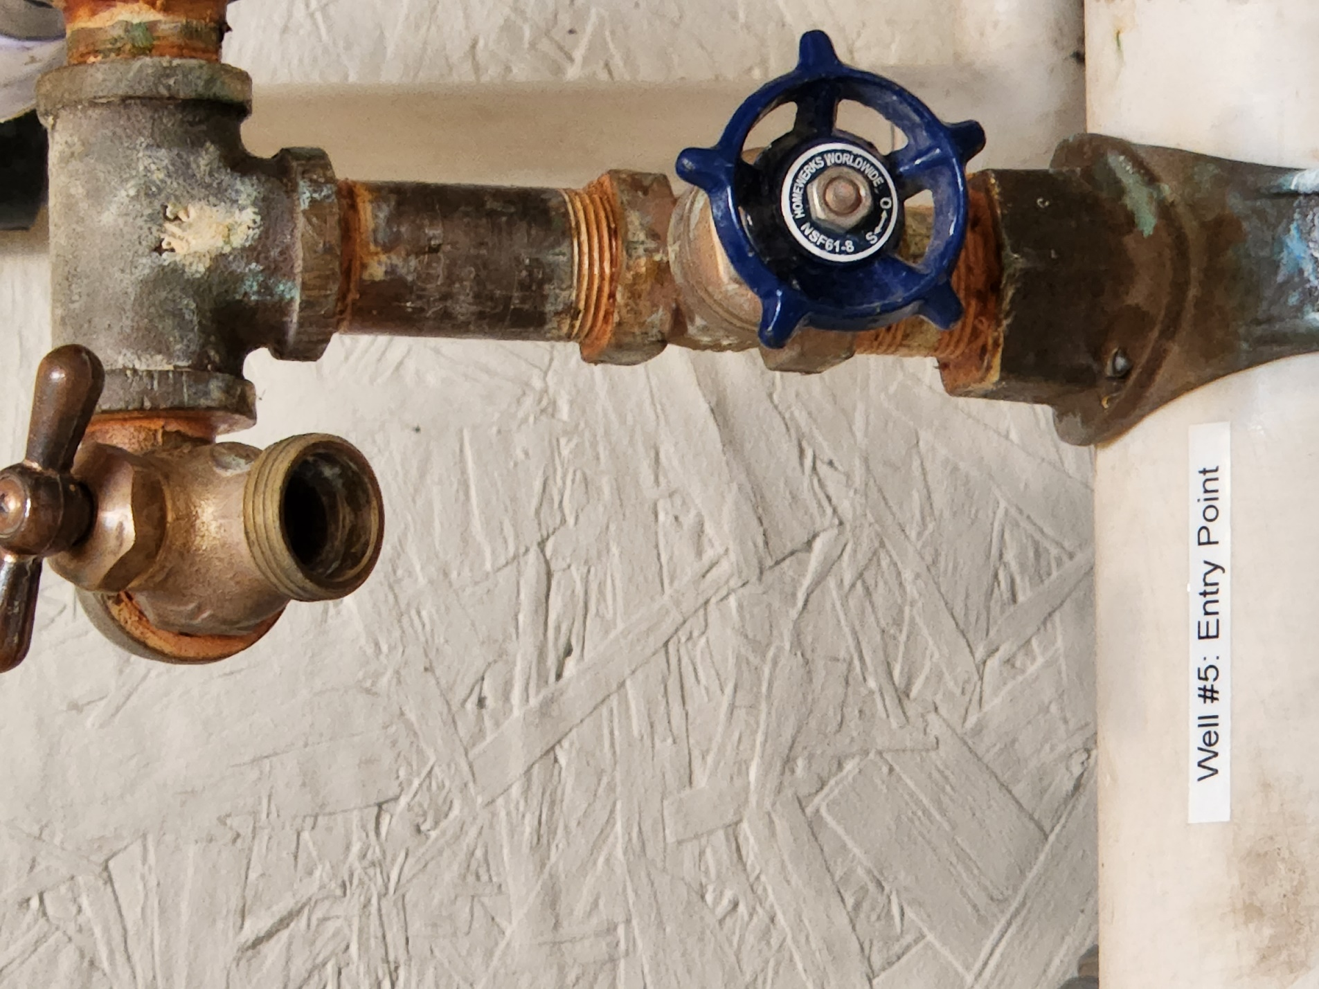
Figure 4: Well #5 Entry Point
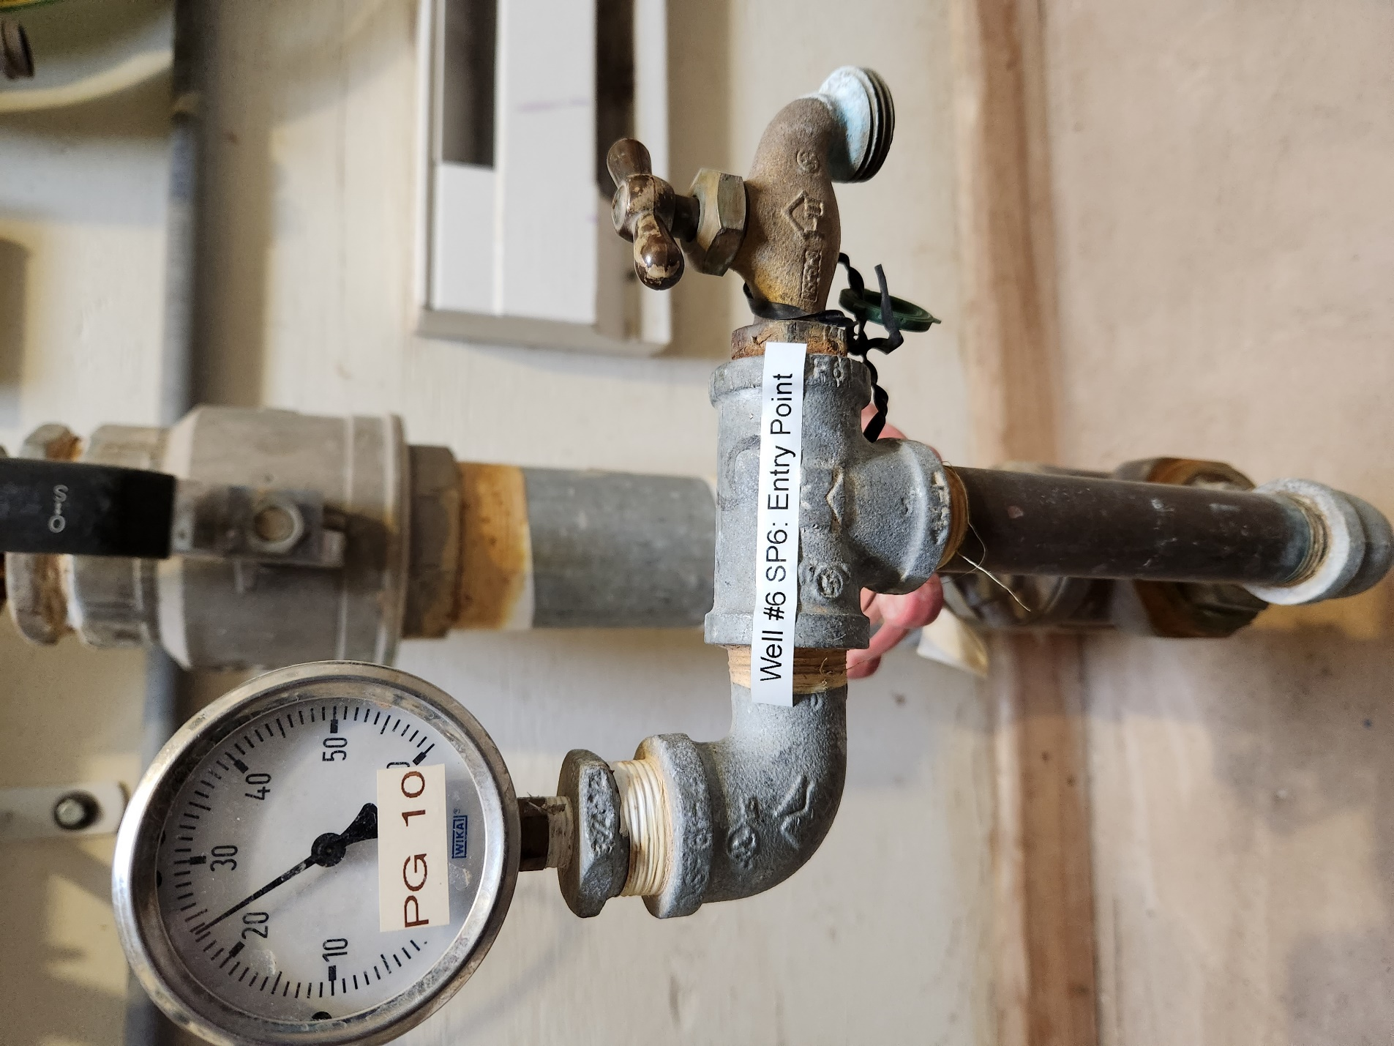
Figure 5: Well #6 Entry Point

Sampling Method
We are subject to Conservation Fund payments to NM Taxation and Revenue at a rate of $0.03 per thousand gallons produced per month, and as such DWB staff samplers collect our EP chemical compliance samples. They are responsible for arranging a visit with us for access to the EP, properly collecting the samples, filling out CoC forms and submitting the samples to an appropriate certified laboratory for analysis. However, we do understand that we are ultimately responsible for the collection of these samples. If the DWB staff sampler has not arranged for their collection within one (1) month of their due date we will either contact the DWB to remind them that the sample(s) must be collected or we will arrange for a certified sampler or operator to collect the samples and submit them to a certified laboratory.

Compliance
Our water system is in compliance if the EP chemical compliance samples are collected according to schedule and chemical concentrations meet all the MCL requirements set forth by the SDWA primary drinking water standards. We are required to, and will notify our DWB CO of any violations and follow all Public Notification Rule and other regulatory requirements in the event of any MCL, sampling or reporting violations.

Section 7: Distribution System Asbestos Sampling
Frequency
We have reviewed our sample schedule on Drinking Water Watch (included in Appendix A) and verified that we are not required to sample our distribution system for asbestos. LMWC has a waiver.
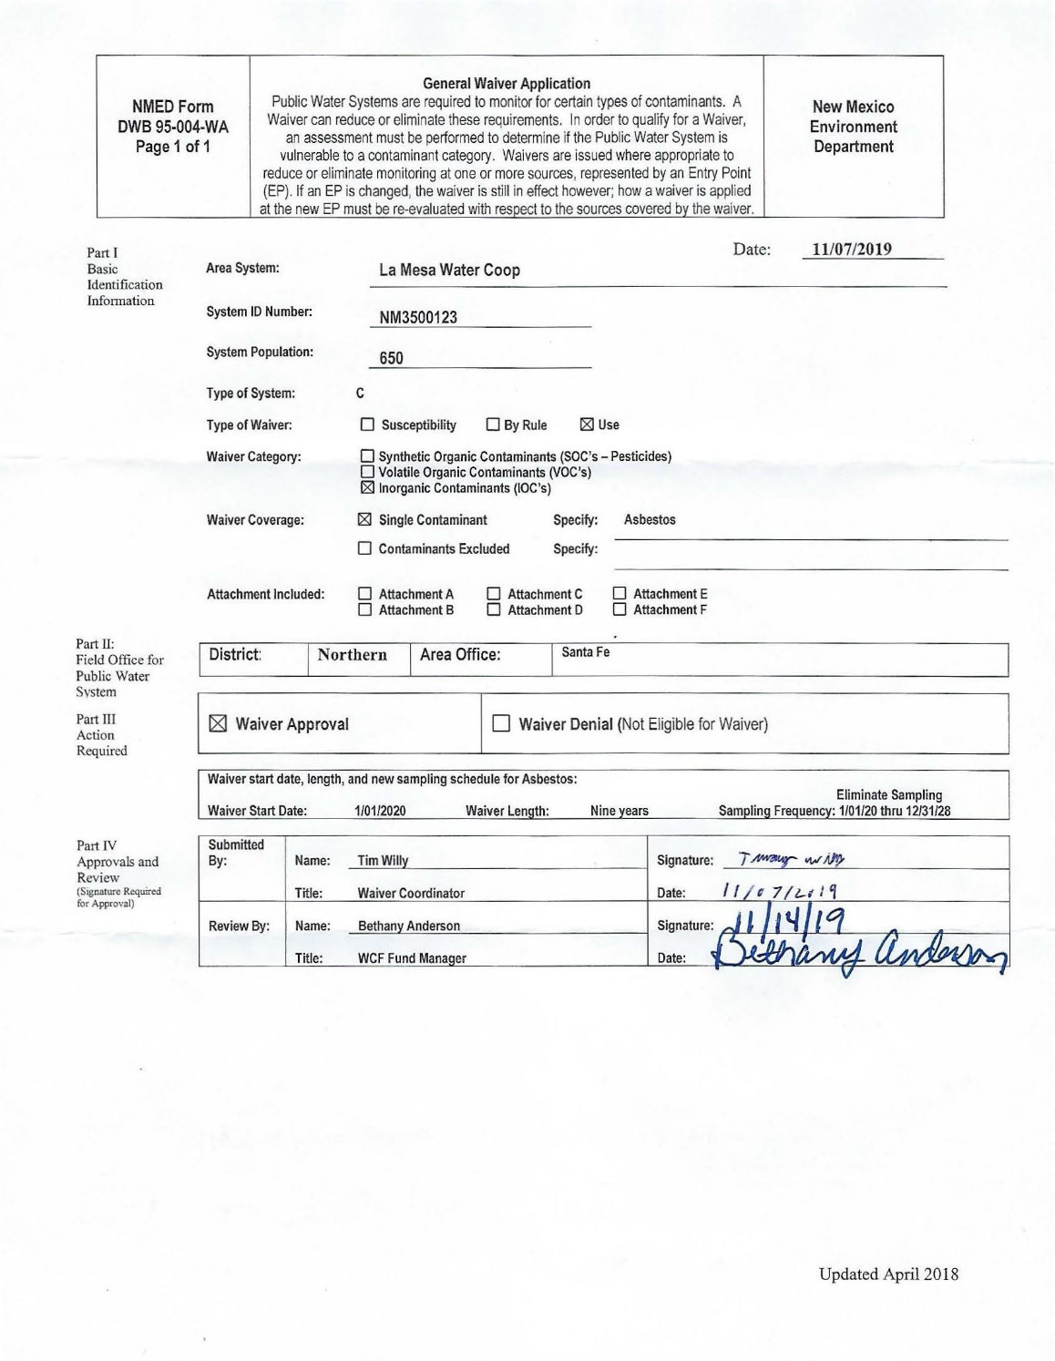

APPENDIX A: System Sample Schedule from Drinking Water Watch
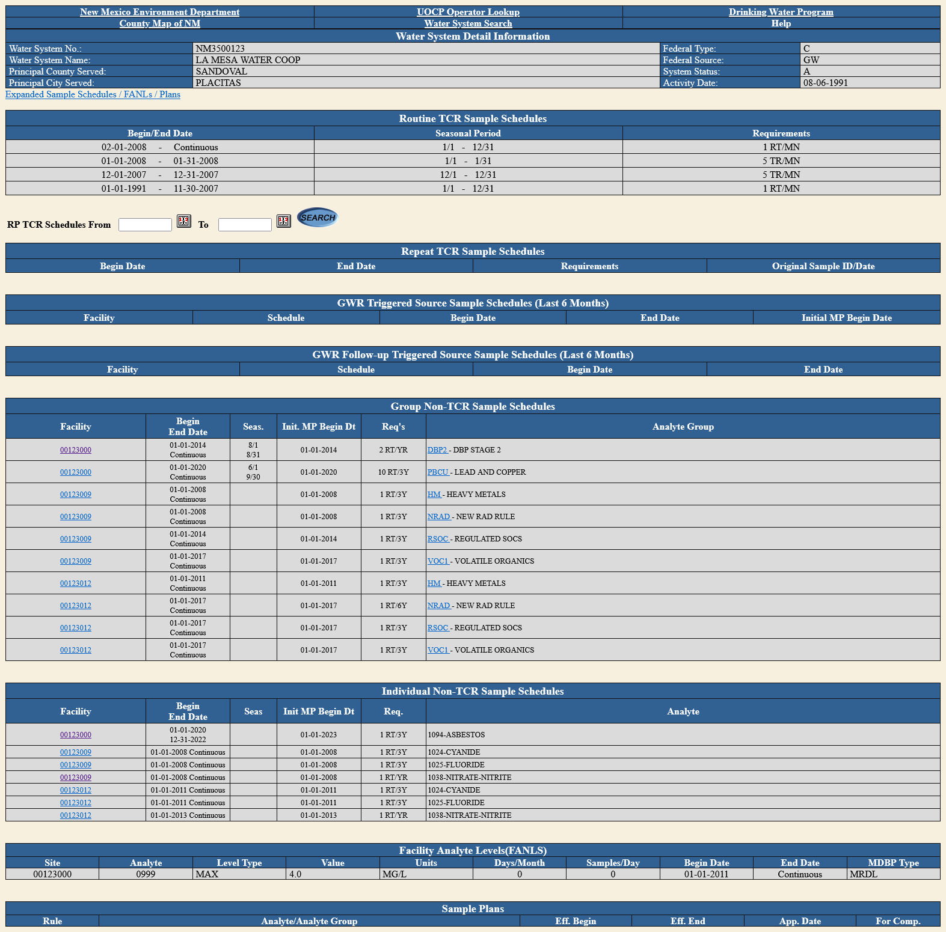

APPENDIX B: RTCR Sample Sites Spreadsheet
RTCR SAMPLE SITES
System Name |  |  | LA MESA WATER COOP
System Number |  |  | NM3500123
Population |  |  | 650
Routine Sample Site Name | Routine Sample Location  (Physical Address or Physical Location) | Repeat Sample Site Name | Repeat Sample Location (Physical Address or Physical Location)
RT001 | 11 Second Mesa  January;  Collected between the 15th and 25th of the month | RP001O | 11 Second Mesa-January; Collected between the 15th and 25th of the month
 |  | RP001U | 04 Alexi Place
 |  | RP001D | 02 Anatoly Court
 |  | RP001UA | SOP required for use of this site - refer to DSSP template instructions
 |  | RP001DA | SOP required for use of this site - refer to DSSP template instructions
RT002 | 41 Santa Ana Loop  February  Collected between the 15th and 25th of the month | RP002O | 41 Santa Ana Loop-February Collected between the 15th and 25th of the month
 |  | RP002U | 50 Santa Ana Loop
 |  | RP002D | 03 Seasons Circle
 |  | RP002UA | SOP required for use of this site - refer to DSSP template instructions
 |  | RP002DA | SOP required for use of this site - refer to DSSP template instructions
RT003 | 02 Calle Montoya  March  Collected between the 15th and 25th of the month | RP003O | 02 Calle Montoya-March; Collected between the 15th and 25th of the month
 |  | RP003U | 173 Camino Barranca
 |  | RP003D | 08 Calle Montoya
 |  | RP003UA | SOP required for use of this site - refer to DSSP template instructions
 |  | RP003DA | SOP required for use of this site - refer to DSSP template instructions
RT004 | 01 Calle del Viento  April  Collected between the 15th and 25th of the month | RP004O | 01 Calle del Viento-April; Collected between the 15th and 25th of the month
 |  | RP004U | 04 Calle Pinon
 |  | RP004D | 11 Calle Pinon
 |  | RP004UA | SOP required for use of this site - refer to DSSP template instructions
 |  | RP004DA | SOP required for use of this site - refer to DSSP template instructions
RT005 | 24 First Mesa  May  Collected between the 15th and 25th of the month | RP005O | 24 First Mesa-May; Collected between the 15th and 25th of the month
 |  | RP005U | 02 Victoria Court
 |  | RP005D | 32 First Mesa
 |  | RP005UA | SOP required for use of this site - refer to DSSP template instructions
 |  | RP005DA | SOP required for use of this site - refer to DSSP template instructions
RT006 | 38 Calle Chamisa  June  Collected between the 15th and 25th of the month | RP006O | 38 Calle Chamisa-June; Collected between the 15th and 25th of the month
 |  | RP006U | 21 Calle Chamisa
 |  | RP006D | 53 Calle Chamisa
 |  | RP006UA | SOP required for use of this site - refer to DSSP template instructions
 |  | RP006DA | SOP required for use of this site - refer to DSSP template instructions
RT007 | 01 Coyote Road  July  Collected between the 15th and 25th of the month | RP007O | 01 Coyote Road-July; Collected between the 15th and 25th of the month
 |  | RP007U | 01 Alexi Court
 |  | RP007D | 03 Deer Road
 |  | RP007UA | SOP required for use of this site - refer to DSSP template instructions
 |  | RP007DA | SOP required for use of this site - refer to DSSP template instructions
RT008 | 101 Camino Barranca  August  Collected between the 15th and 25th of the month | RP008O | 101 Camino Barranca-August; Collected between the 15th and 25th of the month
 |  | RP008U | 100 Camino Barranca
 |  | RP008D | 94 Camino Barranca
 |  | RP008UA | SOP required for use of this site - refer to DSSP template instructions
 |  | RP008DA | SOP required for use of this site - refer to DSSP template instructions
RT009 | 04 Misty Mesa  September  Collected between the 15th and 25th of the month | RP009O | 04 Misty Mesa-September; Collected between the 15th and 25th of the month
 |  | RP009U | 06 Manzano Court
 |  | RP009D | 11 Misty Mesa
 |  | RP009UA | SOP required for use of this site - refer to DSSP template instructions
 |  | RP009DA | SOP required for use of this site - refer to DSSP template instructions
RT010 | 02 Sunset Mesa  October  Collected between the 15th and 25th of the month | RP010O | 02 Sunset Mesa-October; Collected between the 15th and 25th of the month
 |  | RP010U | 104 Camino Manzano
 |  | RP010D | 06 Sunset Mesa
 |  | RP010UA | SOP required for use of this site - refer to DSSP template instructions
 |  | RP010DA | SOP required for use of this site - refer to DSSP template instructions
RT011 | 15 Calle Corvo  November  Collected between the 15th and 25th of the month | RP011O | 15 Calle Corvo-November; Collected between the 15th and 25th of the month
 |  | RP011U | 11 Calle Corvo
 |  | RP011D | 04 Calle Rosa
 |  | RP011UA | SOP required for use of this site - refer to DSSP template instructions
 |  | RP011DA | SOP required for use of this site - refer to DSSP template instructions
RT012 | 85 Camino Barranca  December  Collected between the 15th and 25th of the month | RP012O | 85 Camino Barranca-December; Collected between the 15th and 25th of the month
 |  | RP012U | 94 Camino Barranca
 |  | RP012D | 77 Camino Barranca
 |  | RP012UA | SOP required for use of this site - refer to DSSP template instructions
 |  | RP012DA | SOP required for use of this site - refer to DSSP template instructions

APPENDIX C: Sample Sites
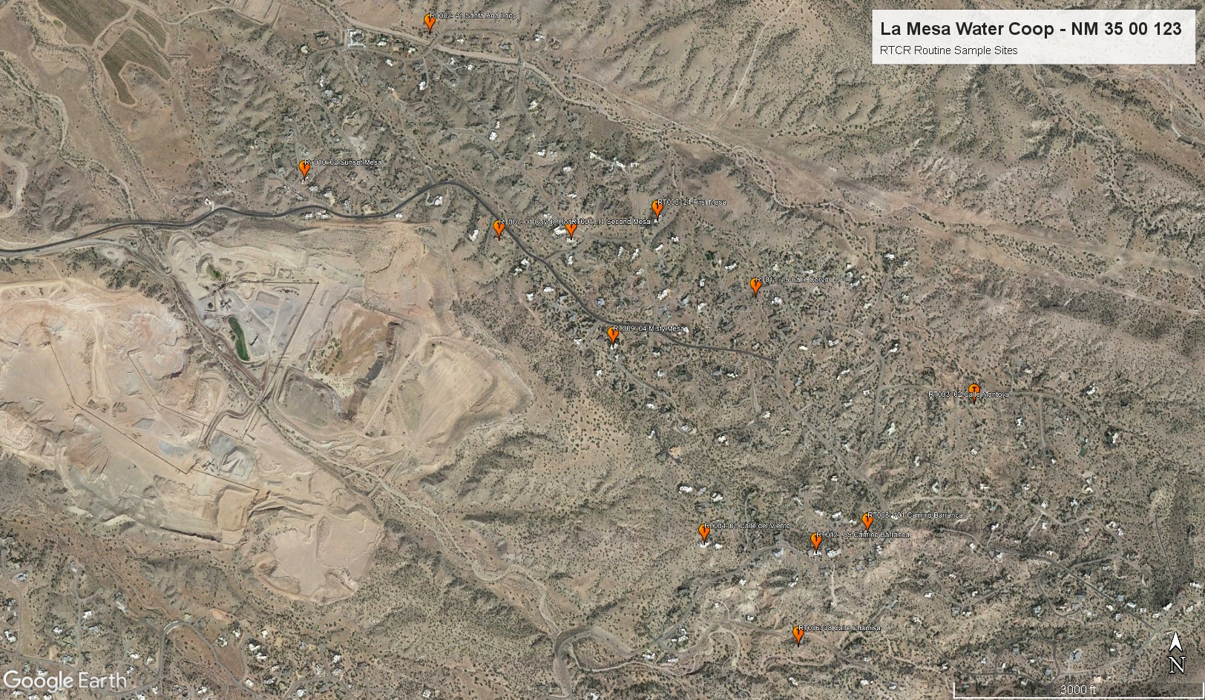
Figure C.1: RTCR Routine Sample Sites
Note: A high resolution PDF version of this map is at:
https://lamesawatercoop.org/LMWC/DSSP/LMWC_DSSP_2022_RTCR_Routine.pdf
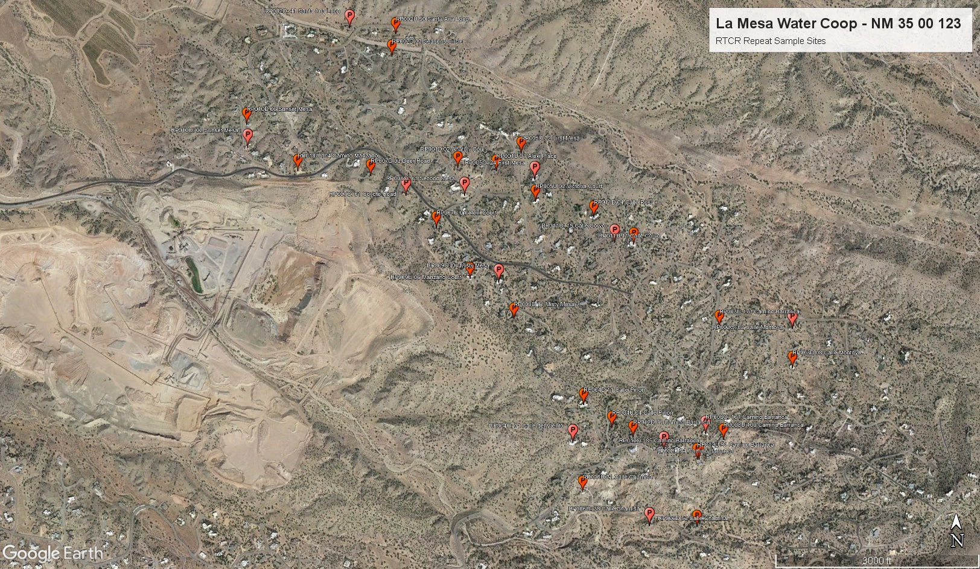
Figure C.2: RTCR Repeat Sample Sites
Note: A high resolution PDF version of this map is at:
https://lamesawatercoop.org/LMWC/DSSP/LMWC_DSSP_2022_RTCR_Repeat.pdf

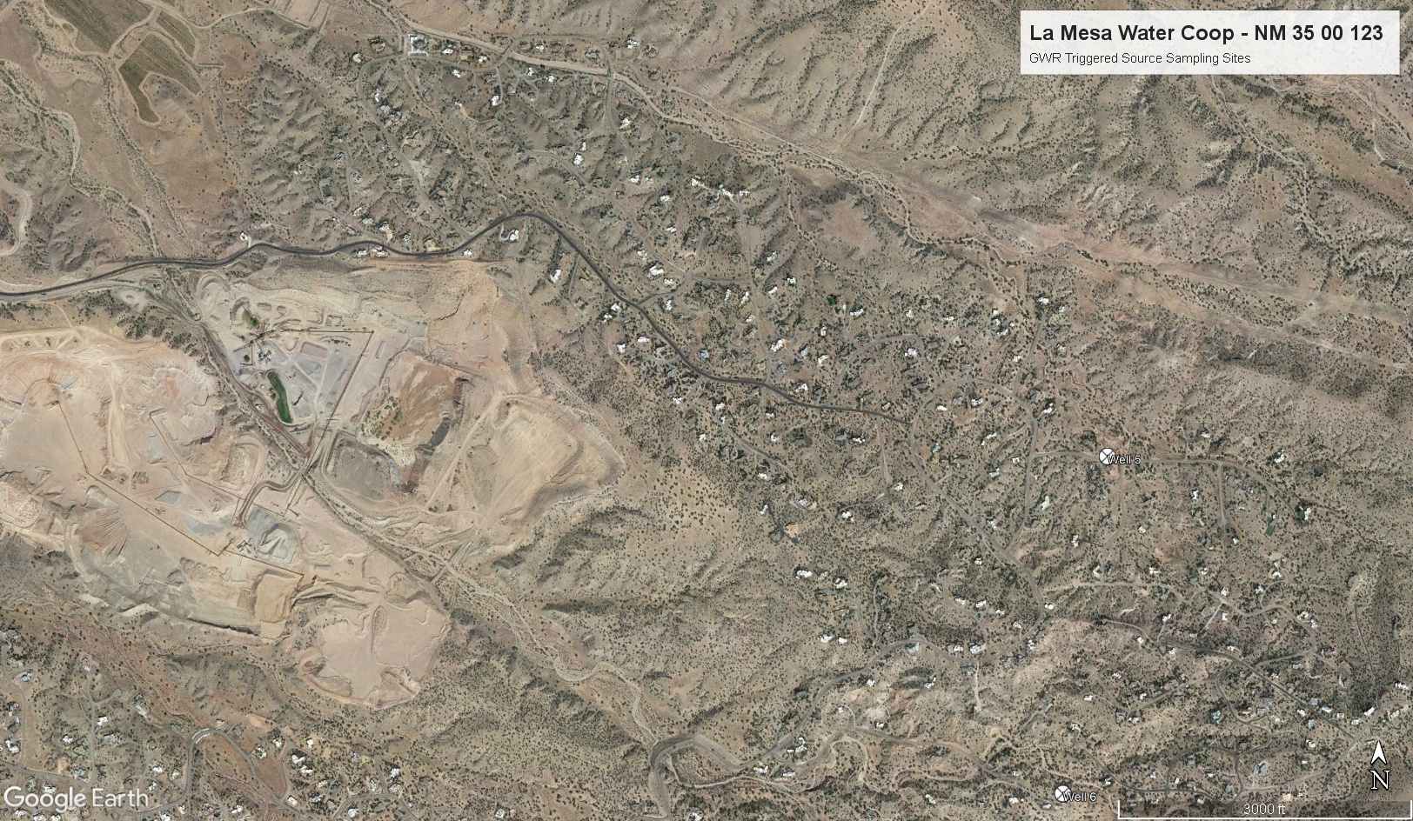
Figure C.3: GWR Triggered Source Sampling Sites
Note: A high resolution PDF version of this map is at:
https://lamesawatercoop.org/LMWC/DSSP/LMWC_DSSP_2022_GWR.pdf

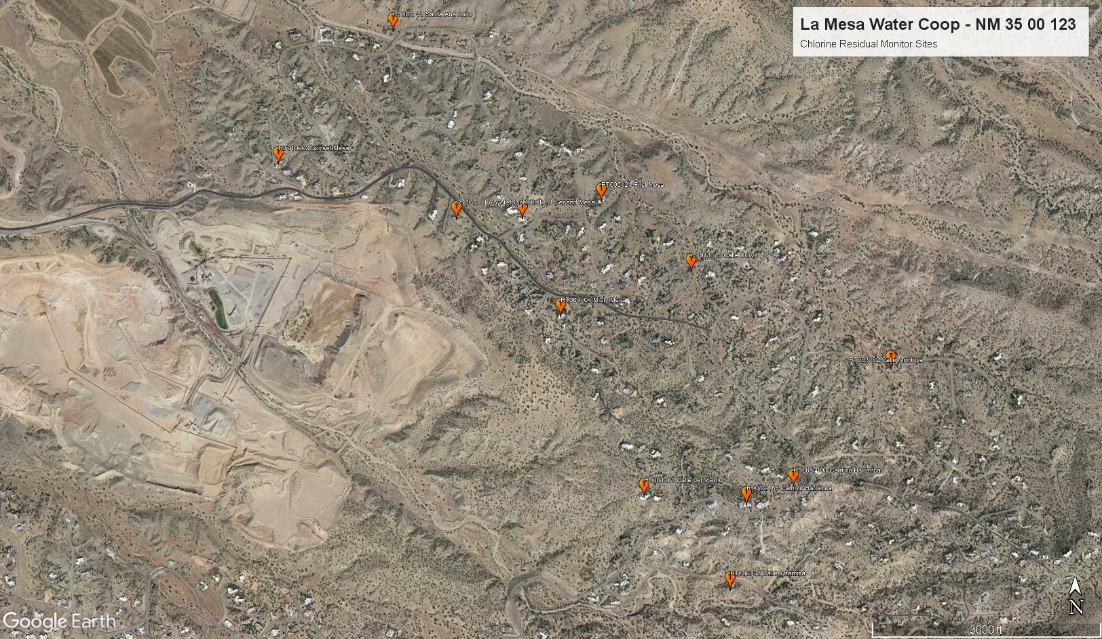
Figure C.4: Chlorine Residual Monitor Sites
Note: A high resolution PDF version of this map is at:
https://lamesawatercoop.org/LMWC/DSSP/LMWC_DSSP_2022_Chlorine_Residual.pdf

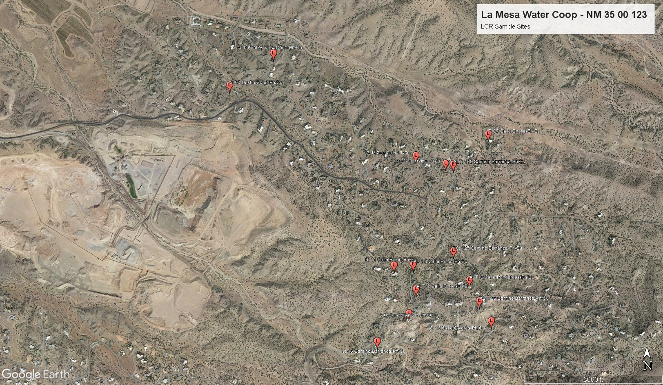
Figure C.5: Lead and Copper Sample Sites
Note: A high resolution PDF version of this map is at:
https://lamesawatercoop.org/LMWC/DSSP/LMWC_DSSP_2022_LCR.pdf

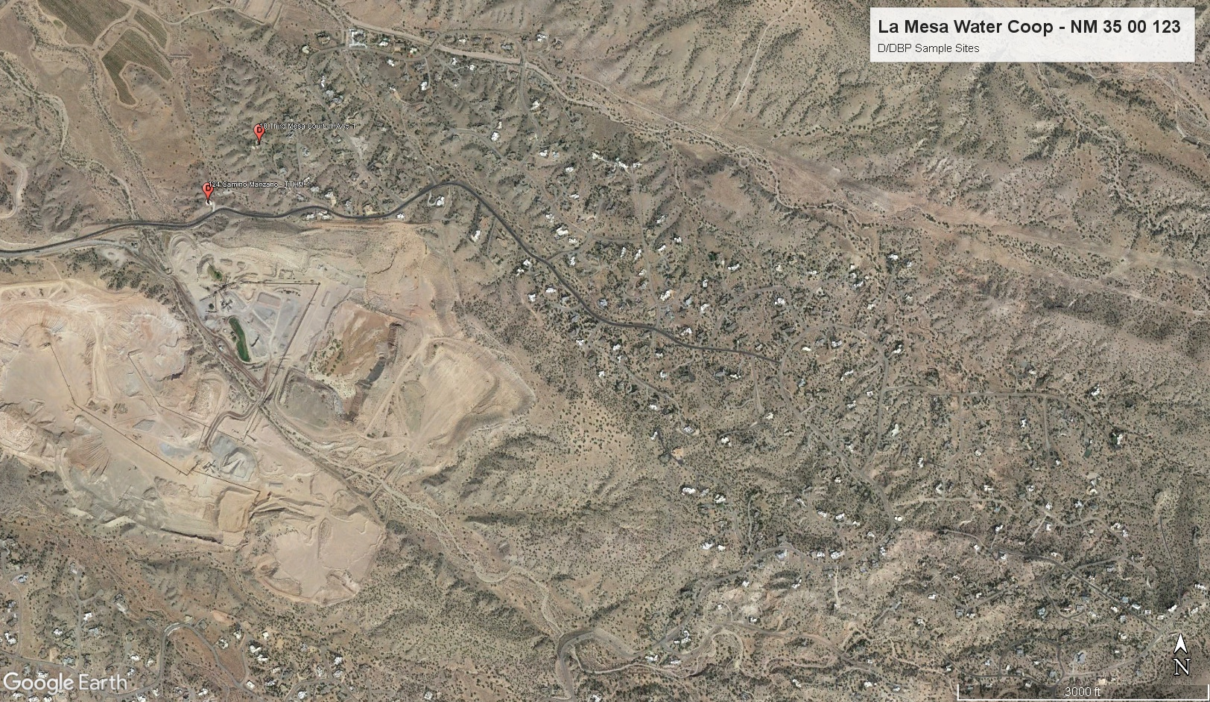
Figure C.6: D/DBP Sample Sites
Note: A high resolution PDF version of this map is at:
https://lamesawatercoop.org/LMWC/DSSP/LMWC_DSSP_2022_DBP.pdf

APPENDIX D: Alternate RTCR Repeat Sampling Sites SOP
Not applicable

APPENDIX E: Disinfectant Residual Report

APPENDIX F: Guidelines for Lead and Copper Site Selection and Sampling

APPENDIX F: Suggested Directions to Homeowners for Sample Collection

